

**MIDDLE EAST TECHNICAL UNIVERSITY**

**ELECTRICAL AND ELECTRONICS DEPARTMENT**

**EE464**

**Static Power Conversion - II**

**Simulation Project 2 Report**

**Isolated Converters & Controller Design**

**Prepared by:**

**Raşit GÖKMEN - 2339760**

**Asım Reha Çetin - 1877257**

**Alma Piric**

**19/04/2018**

**FORWARD CONVERTER DESIGN**

**Simulation:**

A 48V/28V 112W forward converter given below is simulated using simulink.

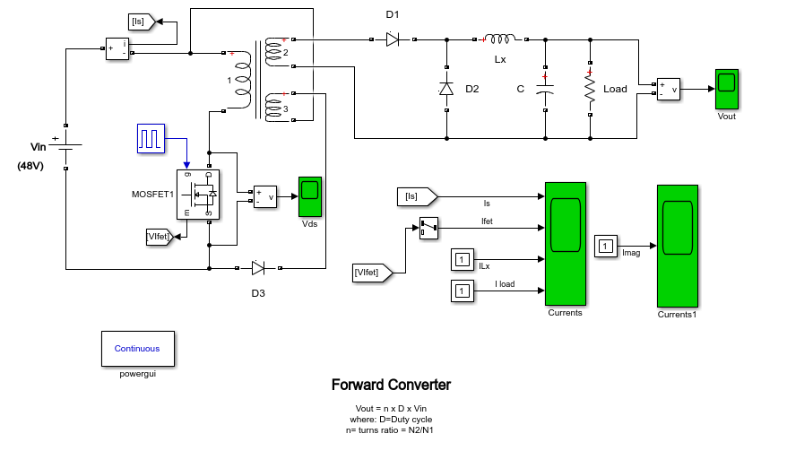

Figure 1: Forward Converter Schematic

The input, output, switch, magnetizing and output inductor currents are observed. Also output voltage and mosfet drain-source voltage are observed.

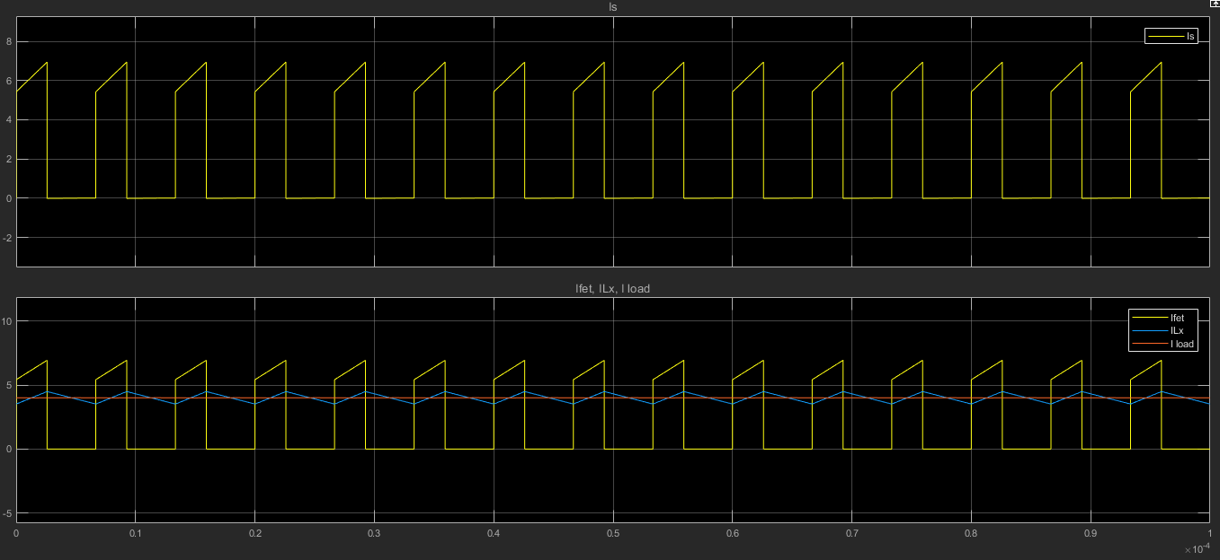

Figure 2 : Input,Output, Output inductor and switch currents.

Above yellow : Input current

Below yellow : Output current

Orange : Load(112W) current

Blue : Output inductor current

As seen below, the on time of switch is measured. The difference between time cursors found 2.59us. A period of switch pwm is 6.67 us. Thus, the switch duty cycle is calculated:

D = $\frac{2.59}{6.67}$* 100% = 38.8%

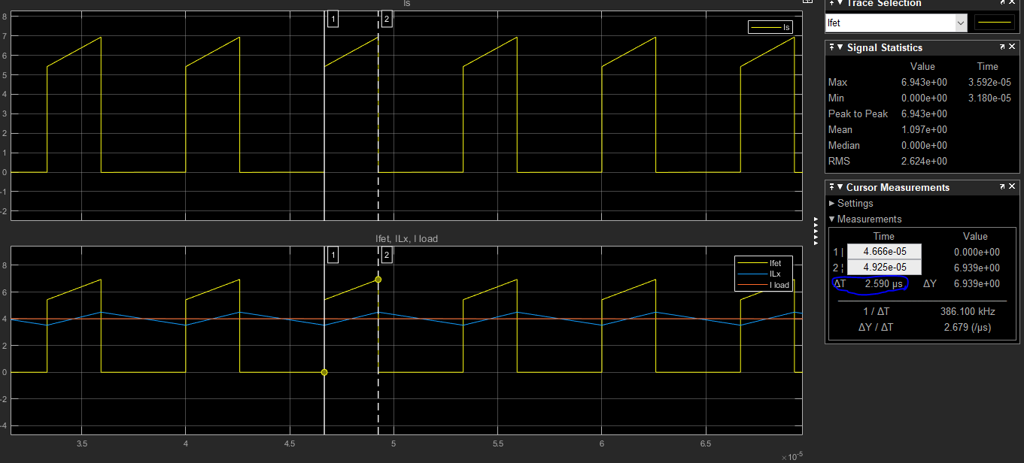

Figure 3: Switch duty cycle measurement

The output voltage is given below. As seen, at transient there is overshoot with 40.6V. In steady state it is settled to 28V.

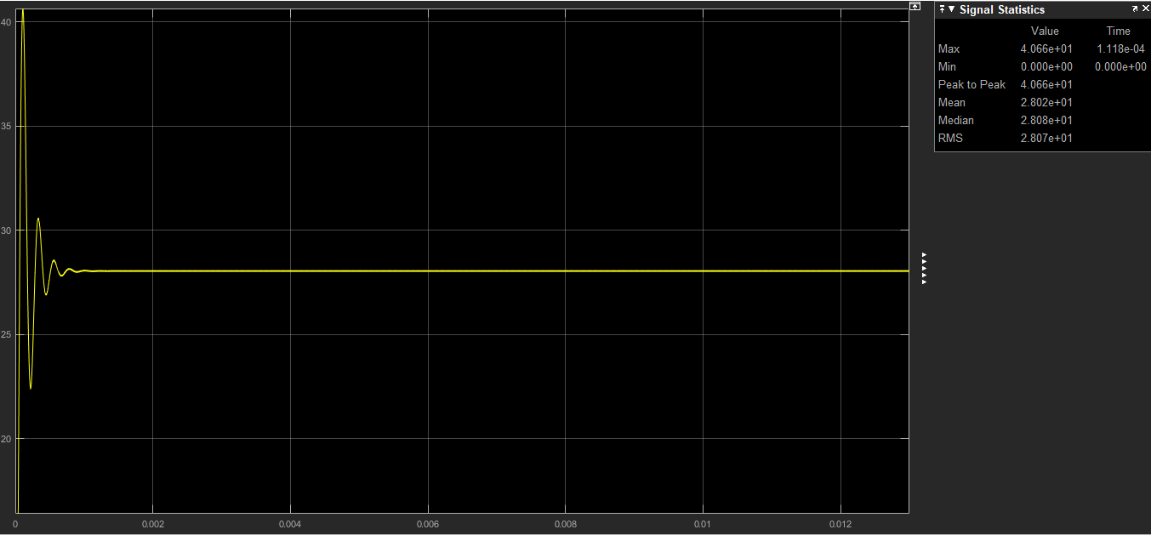

Figure 4: Output voltage waveform

The mosfet drain-source voltage is given below.

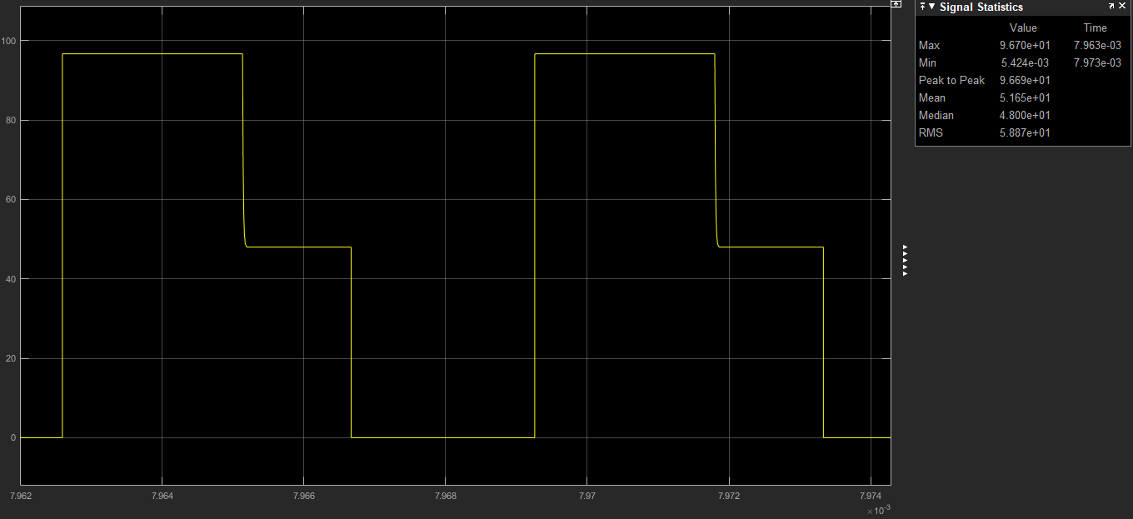

Figure 5: Mosfet D-S Voltage

**Transformer design:**

The transformer turns ratio N1/N2 is calculated 0.67. The turns ratio selected 0.6.

A ferrite core N87 with ETD39 coil former from TDK company is selected.

The core is ungapped and its parameters given below:

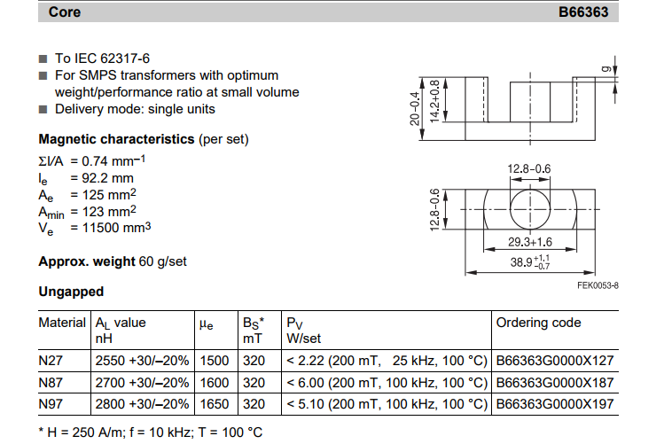

Figure 6: EDT39 N87 core parameters

As seen from figure 6, the AL value of core is 2700nH/n2 . As mentioned the turns ratio is 0.6 . The primary and tertiary winding turns ratio are choosen 6 and secondary winding turn ratio is choosen 10.

Primary magnetizing inductance :

Lm = 2700*62 = 97.2 uH.

With ETD39 core size, minimum primary turns-count in order to guarantee non saturation:

n1 > , n1 = 3.77

which satifies our assumption n1 = 6.

For Vimax = 53V

Dmax = 0.4

Fs = 150 kHz

Bsat = 0.3 T (max allowed core flux density for ferrites to guarantee non-saturation)

Ae = 125 mm2

The turn ratio is wounded with litz wire which has small resistance compared with copper.

The wire is compound of 270x0.05 wire. It has 32.9 ohm/km resistance.

The mean length of one turn for our coil former is 69mm.

At primary :

N1 = 6 turn

Wire length = 6*69 mm = 414 mm = 41.4 cm

Wire resistance = 0.414 * 32.9 *10-3 = 13.6*10-3 ohm

At secondary :

N2 = 10 turn

Wire length = 10*69 mm = 690 mm = 69 cm

Wire resistance = 0.69 * 32.9 *10-3 = 22*10-3 ohm

At primary :

N3 = 6 turn

Wire length = 6*69 mm = 414 mm = 41.4 cm

Wire resistance = 0.414 * 32.9 *10-3 = 13.6*10-3 ohm

Llk is assumed %5 of Lmag .

Llk = 0.05*97.2 = 4.86 uH

Llk1 = Llk / 3 = 1.62 uH

Llk2 = Llk / 3 = 1.62 uH

Llk3 = Llk / 3 = 1.62 uH

Minimum load current to ensure CCM operation:

At boundary Io = $\frac{ΔILo}{2}$

output inductor current rises during on period. The min outpur inductor current ripple hence output current is occured at min ton.

$ΔILo$ = $\frac{VL}{Lo}$*ton

VL = $\frac{N2}{N1}$ Vinmax - Vo - Vdiode

where ton(min) = $\frac{Vo-Vdiode}{Vin max}$ $\frac{N1}{N2}$ $\frac{1}{fs}$** = 2,25 us.

where $\frac{N1}{N2}=0.65$

fs = 150kHz

Vinmax = 52.8 V

Vdiode = 0.7V

Vo = 28V

substuting ton value in above equation :

$ΔILo$ = [ $\frac{N2}{N1}$ Vinmax - Vo - Vdiode ] $\frac{tonmin}{Lo}$



$ΔILo$*

= 0.98 A

where Lo = 120uH

Io = $\frac{ΔILo}{2}$ = $\frac{0.98}{2}$ = 0.49 A which is minimum load current with 120uH output inductor to ensure CCM mode of operation.

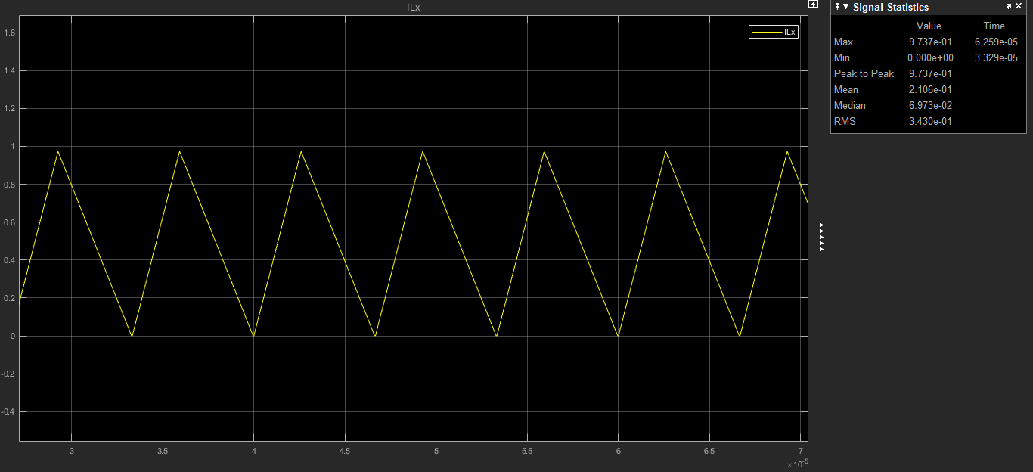

Figure 7: Output inductor current at boundary

**Efficiency Calculation:**

At %100 Load :

At %100 load load current is 4A.

Diode1 loss :

Vf = 0.7 V

Idiode = 2.54A

Ploss = 0.7*2.54 =1.778 W

Diode2 loss :

Vf = 0.7 V

Idiode = 3.10A

Ploss = 0.7*3.10 = 2.17 W

Inductor loss :

Irms = 4A

Rind = 42 mohm

Ploss = 4* 0.042 = 0.0168 W

Main mosfet loss :

Irms = 4.52 A

Ron = 0.24 ohm

Ploss = 4.52*0.24 = 1.0848 W

Transformer loss:

Ploss = 22m * 4.52 + 16m * 2.54 + 16m * 0.3 = 0.145 W

Total Ploss = 5.05 W

Efficiency = $\frac{Pout}{Ploss+Pout}$ = $\frac{112}{112+5.05}$ =0.96 = 96%

At %75 Load :

At %75 load load current is 3A.

Diode1 loss :

Vf = 0.7 V

Idiode = 1.91 A

Ploss = 0.7*1.91 =1.34 W

Diode2 loss :

Vf = 0.7 V

Idiode = 2.34 A

Ploss = 0.7*2.34= 1.64 W

Inductor loss :

Irms = 3A

Rind = 42 mohm

Ploss = 3* 0.042 = 0.126 W

Main mosfet loss :

Irms = 3.48 A

Ron = 0.24 ohm

Ploss = 3.48*0.24 = 0.835 W

Transformer loss:

Ploss = 22m * 1.91 + 16m * 3.48 + 16m * 0.3 = 0.1 W

Total Ploss = 4 W

Efficiency = $\frac{Pout}{Ploss+Pout}$ = $\frac{84}{84+4}$ =0.95 = 95%

At %50 Load :

At %50 load load current is 2A.

Diode1 loss :

Vf = 0.7 V

Idiode = 1.29 A

Ploss = 0.7*1.29 =0.9 W

Diode2 loss :

Vf = 0.7 V

Idiode = 1.58 A

Ploss = 0.7*1.58= 1.1 W

Inductor loss :

Irms = 2A

Rind = 42 mohm

Ploss = 2* 0.042 = 0.084 W

Main mosfet loss :

Irms = 2.45 A

Ron = 0.24 ohm

Ploss = 2.45*0.24 = 0.59 W

Transformer loss:

Ploss = 22m * 1.29 + 16m * 2.45 + 16m * 0.3 = 0.7 W

Total Ploss = 3.37 W

Efficiency = $\frac{Pout}{Ploss+Pout}$ = $\frac{56}{56+3.37}$ =0.94 = 94%

At %25 Load :

At %25 load load current is 1A.

Diode1 loss :

Vf = 0.7 V

Idiode = 0.65 A

Ploss = 0.7*0.65 =0.455 W

Diode2 loss :

Vf = 0.7 V

Idiode = 0.79 A

Ploss = 0.7*0.79= 0.553 W

Inductor loss :

Irms = 1A

Rind = 42 mohm

Ploss = 1* 0.042 = 0.042 W

Main mosfet loss :

Irms = 1.40 A

Ron = 0.24 ohm

Ploss = 1.40*0.24 = 0.336 W

Transformer loss:

Ploss = 22m * 0.65 + 16m * 1.4 + 16m * 0.3 = 0.4 W

Total Ploss = 1.79 W

Efficiency = $\frac{Pout}{Ploss+Pout}$ = $\frac{28}{28+1.79}$ =0.94 = 94%

**Component selection:**

Main switch: As a main switch STL18N65M5 is selected. It has low on resistance. It is features are given below:

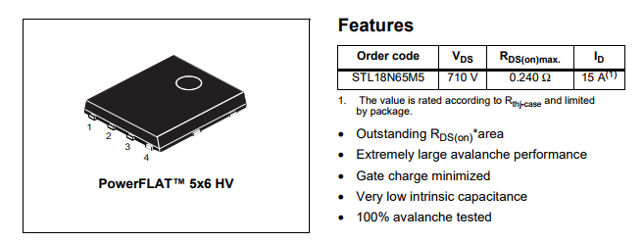

Figure 8 : STL18N65M5 features

For secondary diodes V8P10 - M3 from Vishay selected. It has low forward drop voltage with 100V breakdown voltage and 8A forward current which makes it suitable for our project. It is features are given below:

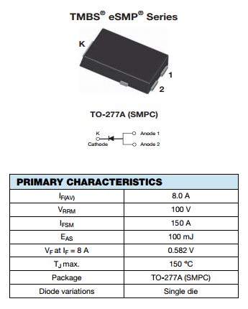

Figure 9 : V8P10 - M3 features

Finally, as an output inductor, 47uH inductor with 8.6A saturation current from vishay company.

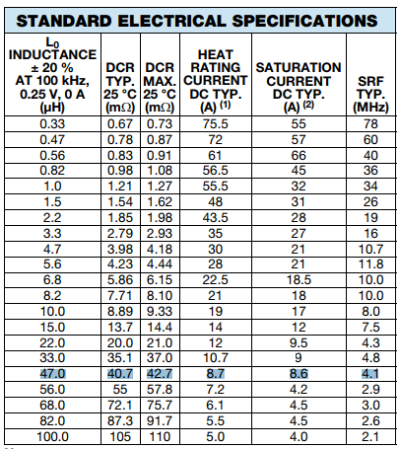

Figure 10 : Output inductor features